|  |  |
| --- | --- |
|  | 4-4 Assignment: UI Design |
|  |  |
|  | Ethan Daugherty  CS-360  3/27/22 |

**Assignment: UI Design**

Coming from a banking background I frequently am asked by customers for additional information about unrecognized charges. Additionally, from being a consumer myself I have asked why information is so limited on the Amazon apps order history page. Amazon tends to separate orders if they are shipped separately, and it doesn’t provide any information about the order unless you expand the item. I chose to redesign this page over information I would like to see made available on.

­­­­­­ 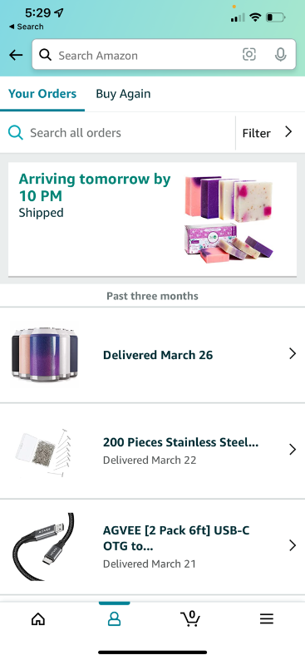

Figure 1: Amazon Order History Page Figure 2: My Redesigned Amazon Order History page

My redesign is similar in that it includes buttons to return to the previous page using a back arrow, check your orders, buy items again sourced from previous purchases, filter orders, load older orders sourced from previous orders, take you back to the home page, and a menu option to explore a user’s subscriptions, account settings, and persona information. My differs by taking the cart and personal information buttons and removing them as they can be found using the menu button. I additionally changed the layout a little and moved the menu button to the top right corner to avoid a cramped bottom of screen. Continuing there is a search option to search all of amazon on the top and a search order history text field to search keywords from your previous orders. If we look at the modular order boxes we have an image of the item ordered, this doubles as a button to bring you back to the items amazon page, the date it is expected to arrive or has arrived, the Order ID, which part of the order is as in way of shipping, the order total, the item total, and a green arrow button to expand on the order details. The load older order button would load more historical orders and the home button below that would take you back to the amazon home screen and your amazon cart.

My redesign follows along with the Core app quality design guide. My redesign would easily encompass both landscape and portrait view and uses the entire screen space. It fits all letters and words in my redesign and there is sufficient space between text and buttons. My redesign choice was made for quality-of-life improvement. I’ve struggled to find order information and what items were ordered together. By including this I can take the confusion out of the question for transactions and help customers recognize orders. By following along with the Core app quality guideline I’ve created a view that is both user-friendly and accessible. I did struggle on finding an application I could improve on this week. With most of the application I use being popular I feel they’re already designed well. This is information I’ve struggled with finding and if I’ve had this problem, I know most other people have as well. Additionally, I did struggle to fit everything onto one screen though overcame this by removing two buttons as they’re found on the menu button.

# References

*Core App Quality*. (2021, 03 17). Retrieved from developer.android.com: https://developer.android.com/docs/quality-guidelines/core-app-quality